**Project Design Phase-II**

**Data Flow Diagram &User Stories**

|  |  |
| --- | --- |
| Date | 16 October 2022 |
| Team ID | PNT2022TMID44952 |
| Project Name | Real-Time Communication System Powered by  AI for Specially Abled |
| Maximum Marks | 4 Marks |

**Data Flow Diagrams:**

A Data Flow Diagram (DFD) is a traditional visual representation of the information flows within a system. A neat and clear DFD can depict the right amount of the system requirement graphically. It shows how data enters and leaves the system, what changes the information, and where data is stored.

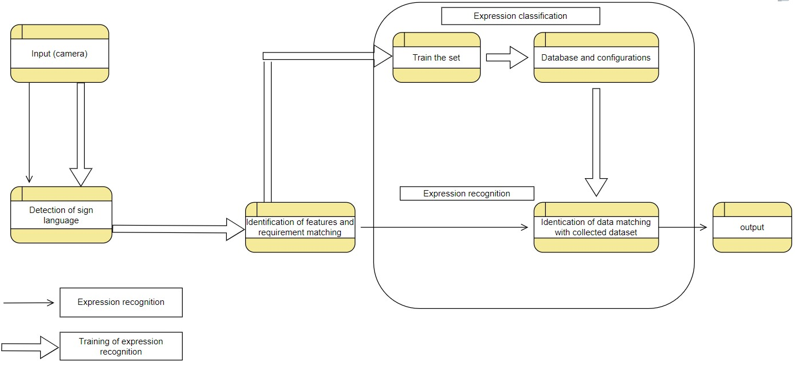

**User Stories**

Use the below template to list all the user stories for the product.

|  |  |  |  |  |  |  |
| --- | --- | --- | --- | --- | --- | --- |
| **User Type** | **Functional**  **Requirement (Epic)** | **User Story**  **Number** | **User Story / Task** | **Acceptance criteria** | **Priority** | **Release** |
| Customer  (Mobile user) | Registration | USN-1 | As a user, I can register for the application by entering my email, password, and confirming my password. | I can access my account / dashboard | High | Sprint-1 |
|  |  | USN-2 | As a user, I can register for the application through Gmail | I can access my account / dashboard | High | Sprint-1 |
|  | Confirmation | USN-3 | As a user, I will receive confirmation email once I have registered for the application | I can receive confirmation email & click confirm | High | Sprint-1 |
|  | Login | USN-4 | As a user, I can log into the application by entering email & password | I can enter into the login by id and password | High | Sprint-1 |
|  | Data input | USN-5 | User will be giving the input, the camera as speech or signs | I can give the input to the system | High | Sprint-1 |
|  |  | USN-6 | The system will take the input for the testing will the given data base | The will accept the input for the testing | High | Sprint-2 |
|  | Data verification | USN-7 | It will verify with the data base that will match with the input | Configuration of the input | High | Sprint-2 |
|  |  | USN-8 | Identification of the input and convert into the text if the input is signs or as signs | Identification of the input and creating output | High | Sprint-3 |
|  | Output Display | USN-9 | Display the output on the screen for the user | Display of the output | High | Sprint-4 |